CUA Modified 4 Umpire Mechanics

Basic Principles
- Make eye contact with your partners if there is any doubt about whose call it is.
- Communicate, Communicate, Communicate.
- Box in the runner during a rundown. U1 or U3 will take the outside, and U2 will take the inside on rundowns in the infield.
- Obstruction/Interference: We have multiple sets of eyes, so be sure to follow your runner’s responsibilities and call any obstruction or interference.
- Get two sets of eyes on trouble balls and home runs.
- Utilize the “Train Tracks” principle to best see plays at the bases
- Infield catch coverage-See attached diagrams
- Balk concentration-See attached
- If the crew needs to come together, the entire crew will meet
- If there is a protest the PU (Crew Chief) and U2 will go to the locker room. U1 and U3 will remain on the field.

Plate Umpire (PU)
- Fair/Foul: The PU has responsibility up to the base; U1 and U3 have responsibility at and beyond the base.
- The PU has primary responsibility for balls entering dead-ball territory in the infield, up to the bases.
- With no runners on and a ball in the infield, the PU will move up the first-base line to help with pulled-foot calls, swipe tags, and to observe runner’s lane interference (RLI).
- The PU will observe all touches of first base and third base if U1 or U3 go out.
- The PU has no fly ball responsibilities in the outfield.
- If U3 must move to second base for a call, the PU will move (in foul territory) to third base and take all calls and touches there.
- With a runner on third base, if U3 goes out on a catch/no-catch in left field, the PU is responsible for the tag-up at third base.
- With a runner on first base, if U1 goes out on a catch/no-catch in right field, the PU is responsible for the tag-up at first base.
- Observe the batter for potential bat-flip violations.
- Record all lineup changes (substitutions), conferences, meetings, and courtesy runners.

First Base Umpire (U1)
- Position yourself 2–3 steps behind the first baseman, in foul territory. Stay at least 6 steps from first base, even if the first baseman is playing in. Do not straddle the line.
- Responsible for fair/foul calls on balls that hit or pass first base.
- Responsible for balls out of play beyond first base toward the outfield.
- Responsible for check swings appeals on right-handed batters.
- With U2 in the outfield:
  - Responsible for catch/no-catch if the right fielder moves toward the foul line.
  - To “go out,” turn your back to the plate and take 2–4 steps down the foul line (no farther).
  - If you go out:
    - The PU will cover touches and tags at first base (rare).
    - After the outfield play, return to first-base responsibilities.
- With U2 in the infield (runners on any base except a runner on third only):
  - Responsible for catch/no-catch on balls where the center fielder moves straight in, straight back, or toward the right-field line, and all balls to the right side of the outfield.
- Foul territory catches: Box in the play with the PU unless you have runner responsibilities.
- Runner situations:
  - If a runner is held on first, move to 4–6 feet from the bag in foul territory.
  - If the runner is not held, be alert for a back-pick from the catcher; move into position after the pitch is completed.
- If the PU rotates to third:
  - U1 rotates (in foul territory) to home plate for all calls there.
  - Do not commit to home until the batter-runner touches second base.
- Responsible for the conduct of the first-base dugout.
- Maintain the stopwatch: signal 30 seconds remaining for pitcher warmups.

Second Base Umpire (U2)
- With no runners or only a runner on third, position yourself on the outfield grass over the inside shoulder on the middle infielder.
- Responsible for catch/no-catch inside the “big V.” This includes all fly balls from the left fielder straight in and straight back to the right fielder straight in and straight back.
- U2 will go out on all outfield fly balls (2–4 steps; no farther).
- Base hits (starting from the outfield):
  - Move into the infield and get an angle for plays at second base.
- Extra-base hits in U1 or U3 coverage area:
  - Stay outside the baseline and make calls from the outfield side of second base.
- With runners on base (except runner on third only):
  - Position in deep “B” (two steps on the grass at the cutout, facing the third-base line).
- Responsible for all touches and tag-ups at second base.
- On double plays:
  - Stay on the play at second base for a voluntary release, interference or illegal slides.
  - Do not follow the throw to first base.
- U2 replaces the plate umpire if the PU cannot continue due to injury or illness.

Third Base Umpire (U3)
- Position yourself 2–3 steps behind the third baseman in foul territory. Stay at least 6 steps from third base. Do not straddle the line.
- With a runner on third, you may move inside the foul line for a better angle if necessary.
- Responsible for fair/foul calls on balls that hit or pass third base.
- Responsible for balls out of play beyond third base toward the outfield.
- Responsible for check swing appeals on left-handed batters.
- Infield catch responsibilities: See Umpire Manual (attached).
- For most plays at third base:
  - Stay in foul territory; avoid interfering with the runner.
  - On steals, move just inside the line for a better look.
- With U2 in the outfield (no runners on or R3 only):
  - Responsible for catch/no-catch if the left fielder moves toward the foul line.
  - To go out, turn your back and move 2–4 steps down the line (no farther).
  - If you go out:
    - The PU covers tag-ups at third base.
    - Return to make calls at third base after the play.
- With U2 going out (no runners or runner on third only):
  - Slash to second base and take all calls on the batter runner there.
  - Remain at 2B until the play ends.
  - The PU moves to third base, U1 rotates to home.
- With U2 in the infield (runners on base):
  - Responsible for catch/no-catch on balls where the center fielder moves to his left toward the left-field line, and all balls to the left side of the outfield.
- Foul territory catches: Box in the play with the PU unless you have runner responsibilities.
- Responsible for the conduct of the third-base dugout.
- Assist the PU in recording conferences, meetings and courtesy runners.

No Runners on base

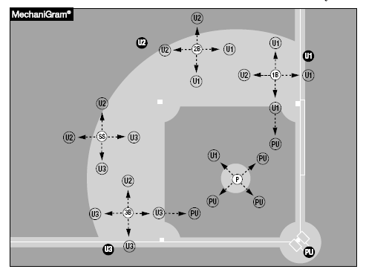
Runners on Base
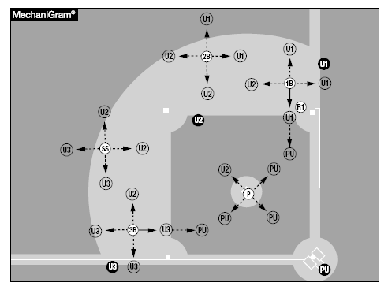

Balk Concentration
There are some balks that are more obvious from some positions.
- PU should concentrate on:
  - Left-handed pitchers stepping to the plate
  - Left-handed pitchers coming to a complete stop
  - Right-handed pitchers coming to a complete stop
  - Right-handed pitchers gaining ground on the jump turn
  - Right-handed pitchers closing their shoulder before the jump turn
- U1 should concentrate on:
  - Left-handed pitcher’s step, or body movement to the plate
  - Left-handed pitchers coming to a complete stop
  - Right-handed pitchers breaking their front knee before the jump turn
  - Right-handed pitchers gaining ground on the jump turn
- U2 (when inside) should concentrate on:
  - Left-handed pitchers coming to a complete stop
  - Right-handed pitchers coming to a complete stop

- U3 should concentrate on:
  - Right-handed pitchers coming to a complete stop
  - Right-handed pitchers stepping to the plate on the third to first move
  - Left-handed pitchers stepping to the plate

